Pav Szymanski
Student Number: 18038404
MA Fine Art Digital
pavszymanski@gmail.com
p.szymanski0720181@arts.ac.uk

Title:
Through critical analysis of Büchel’s “BARCA NOSTRA” and Balka’s “HOW IT IS?” this research paper aims to question the perception of certainty in the context on ambiguity. The philosophical framework for this process is firmly placed within the concept of the Uncertainty Principle by Heisenberg (1927), anschaulic and the Theory of Knowledge by Russell (1926).

Research Statement
MA Visual Arts: Fine Art Digital
Camberwell College
University of the Arts London
Course Tutor: Jonathan Kearney
04 October 2019

Key words:
Certainty, ambiguity, perception, illusion and the end.

Abstract:

The aim of this research paper is to critically analyse the interdependence between the element of questioning within the work by Buchel (2019) and Balka (2008).
The initial part of this document looks at the “Principle of Uncertainty” by Heisenberg (1927) in order to explore the complexities of the meaning of uncertainty through the prism of these two artists.
The second section expands on the theoretical framework and appraises the “Theory of Knowledge” by Russell (1926).
The next part critically analyses the broader implications of each piece independently. It subsequently attempts to identify a link between, both artistic perspectives, in order to instigate a discussion about the possible interpretations of the concept of uncertainty.
Ultimately, the paper develops a hypothesis that the origin of uncertainty is multi-levelled, poly-layered and of a totally unknown velocity, direction and destination. The only certainty is the ambiguity of the experience of the ‘journey’ and the knowledge that it will end.

Introduction:
The absence of certainty is deeply rooted in human nature. Travel experiences allow people to observe uncertainty across a wide spectrum of cultures, locations and contexts. The contextual framework enables a philosophical viewpoint to be taken into account in any attempt to try to understand this phenomenon. Curiosity is firmly embedded into the analysis of art. It enhances the overall understanding and reveals the hidden dimensions that cause the uncertainty in life.

“Whenever we proceed from the known into the unknown we may hope to understand, but we may have to learn at the same time a new meaning of the word 'understanding.”

(Heisenberg, 1958:201)

Alok (2013) argues that the Uncertainty Principle articulated by Heisenberg (1927) is frequently regarded as one of the most distinct features, which differentiates quantum mechanics from the classical understanding of physics. The essence of his discovery states that the position and momentum of an object cannot be simultaneously and precisely measured, even theoretically. These quantities can only be assessed with a degree of “uncertainty” and within the tolerance of a mistake.
One could argue that the entire enjoyment of reading literature and watching the cinema is much enhanced by the emotion of suspense and anticipation. Human beings tend to enjoy not knowing and this bizarre sensation allows them to speculate, weigh probabilities and plot.

The concept of “uncertainty” is prevalent in literature. It is frequently used to describe a degree of ambiguity or lack of knowledge. Other examples refer to errors in measurements of inaccuracy of equipment, which is used in order to quantify experimental outcomes, findings and data. There are several synonyms used, such as imperfection, indefiniteness, indeterminateness, average, imprecision, indeterminacy, and latitude. All of the above terms imply imperfection.
This track of thought, in turn, must lead to questioning how one knows that uncertainty exists. Therefore, it can be assumed that the “Theory of Knowledge” by Bertrand is a product of an attempt to analyse doubt. Further consideration will be given to a dialogue between the thinking of Kant and the scepticism of Hume.
In subsequence, this line of enquiry will create a solid contextual framework for the critical analysis of both pieces of art: “BARCA NOSTRA” and “HOW IT IS?”
The intention here is to discuss and question uncertainty using two distinct perspectives. The first is a functional object, which through experience, becomes a controversial artefact. The second is manufactured to a specification in order to communicate an ideas in response to the broader contexts.
The conclusive part of this paper will question the ability to embrace this concept, accept the total lack of control and understand the paradox between certainty and ambiguity. The more certain we think we are, the more unexpected life becomes.

The Principle of Uncertainty by Heisenberg (1927)
Hilgewood (2016) proposes that Heisenberg devoted most of his professional life to the study of quantum mechanics, especially the Uncertainty Principle. He proved his theory through a long process of mathematical elaboration. When his famous article was first published (Heinsenberg, 1927 in https://plato.stanford.edu/entries/qt-uncertainty/), the title contained a German term: “anschaulich”. The meaning of this word contradicts preciseness and roughly translates as visualisable, intuitive and lucid. The defined and exact language of science has suddenly become very vague and ambiguous. The distinct and revolutionary invention of his article was the presumption that the exact values cannot be assigned to all physical quantities. He describes his thought processes using a very concise statement as follows:

“It has turned out that it is in principle impossible to know, to measure the position and velocity of a piece of matter with arbitrary accuracy”.

(Heisenberg, 1984:26) in Hilgevoord (2016), available https://plato.stanford.edu/entries/qt-uncertainty/)
Heisenberg’s revolutionary thinking proposal can be interpreted as a universal lack of certainty in life. Our direction and position are impossible to be ascertained and measured with reliable accuracy. We are able to set a path to follow in order to base are journey through life on a structured foundation. This gives us an illusionary sense of certainty and destination. We move along it towards self-realisation and in order to make an attempt to fulfil our dreams, aspirations and ambitions. Our pace and position are, however, unknown. We can make an estimate through analysis and evaluation, but this is only relative, average and imperfect.
The paradox is that while knowing that our lives are uncertain, we strive, plan and organise our future as though there was a degree of certainty and predictability giving us a sense of comfort and security whereas in reality, there is nothing for sure (sic!).

Ring (2016) extends on this by differentiating between risk and uncertainty. While risk means that we are certain of probabilities. Therefore, we are able to calculate their chance of occurrence before making appropriate assessments. Uncertainty means that there is a lack of the necessary knowledge in order to make valid predictions and decisions.
Within human nature, we seek risk-taking, gambling and extra uncertainty to add thrill, colour and excitement to the mundane existence.
Paradoxically, we also take risks in order to increase certainty of the future, frequently making it more uncertain.

Ellsberg (1961) expands further on this concept by suggesting that this lack of information may lead to “The ambiguity effect”. He describes this phenomenon as a form of cognitive prejudice affecting our decision-making capabilities. He also implies that our preferred option is always to focus on the least unpredictable and unknown rather than on possibilities, which have a greater amount of risk involved.

Heisenberg’s theory refers to the velocity and location of very small structures. Therefore, some philosophers deny quantum uncertainty. Our lives and their trajectory remain very uncertain, unpredictable and impossible to measure with appropriate preciseness. Life and its notions are nothing more than guesswork.

Theory of Knowledge by Russell (1926):
Bertrand (1914:70) suggests applying the logical-analytical method to any attempt to understand the problem of our knowledge of the world, which is external to us. He also argues that the solving of every philosophical problem should start with “data”, include common knowledge, vague information, complex figures and inexact materials.
The Theory of Knowledge, which he subsequently developed was born out of his self-doubting and self-questioning. Is it possible to reliably establish what we know? How do we know that we know and how can this knowledge can be measured? He also distinguishes between knowledge and belief. He argues that a belief is a relative to a state of mind. We follow plans in the hope that they will be accomplished. He extends on this statement and proposes that our faiths are influenced by our perception of truth and falseness.
However, when attempting to formulate the definition of knowledge, two further factors must be taken into consideration, such as certainty and precision. How certain are we of data and how precisely that data can be analysed and interpreted? He also considers two distinct categories of data: mental and physical. He differentiates between data, which are affected by memory, expectation and feelings, and data, which are collected via an objective research activity. (Russell, 1926 in https://www.marxists.org/reference/subject/philosophy/works/en/russell1.htm)

Heisenberg has already established through his presumption that the exact values cannot be assigned to all physical quantities.
Therefore, can our knowledge be quantifiable and measurable?
What is becoming even more apparent is the existence of uncertainty and doubt. We appear to be acting on complete submission to our future plans, but in reality, there is always an integral element of caution, which allows us to reflect and evaluate in order to introduce quality improvements, refinements and developments.

The impact of Humes’s philosophy on the Theory of Knowledge by Kant.
Kant’s Theory of Perception consists of two concepts, which are involved in the process of knowing. The first one is sensibility and the second understanding. He refers to the diametrically different natures of receptive and intuitive sensibility and active understanding. Contextualisation of concepts and their content are very important in order to achieve full understanding and achieve knowledge. (Pritchard, 2017)
Hume in turn focuses on experience, which consists of feelings, images and sounds. His philosophy is based on the idea of doubt, questioning and looking for flaws in all proposed arguments, including his own. His understanding of our mental perception of the Universe is based on two pillars: ideas (thoughts) and impressions (sensations and feelings). His main argument is that everything we know is only derived from our impressions and that limits our independence. We form opinions about the world, because we are affected and susceptible to impressions.
Kant’s interpretation of The Theory of Knowledge places it somewhere in between rational thinking and empirical experience. He believes that knowledge is gained exclusively a priori. David Hume and other empiricists claim that knowledge is strictly related to sensitivity and, therefore, a posterori. All concepts are strongly dependent on sensitivity and originate from our perception. They cannot be autonomous.
He also believes that knowledge is based on facts and this interdependence cannot happen a priori.
In contradiction, Kant does not support this line of argument and links causality with rationality. Therefore, his position places knowledge somewhere in the centre, in between the boundaries of rationalism and empiricism. All knowledge comes from two sources, such as sensitivity and understanding, which must be both integral to the process of knowledge.

Critical Analysis of “Barca Nostra (Our Boat)” by Büchel, 2016.
Harris (2019) proposes that a statement, which was released to the press in support of Büchel’s project is the best way of contextualising the piece:

“The public exhibition of Barca Nostra at the Arsenale—in the context of the cultural spectacle and economic operation of the Biennale in Venice, a city based on migration that feeds the machine of its own destruction through mass tourism—opens up the possibility of actively using the collective shipwreck Barca Nostra as a vehicle of significant socio-political, ethical, and historical importance.”

Harris, G., (2019), available at: https://www.theartnewspaper.com/news/after-mosque-row-christoph-buechel-returns-to-the-venice-biennale-with-migrant-shipwreck.
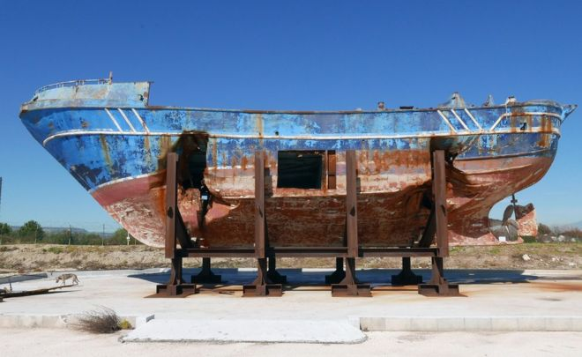
Büchel, (2016), available at: https://www.bbc.co.uk/news/world-africa-48252938

This artefact has a multiple meaning and refers to a whole spectrum of the broader contexts of the 21st century, such as immigration, hope and exploitation. Its title refers to a policy, which was formulated by the Italian government in 2013 called Mare Nostrum (Our Sea). This parliamentary act was instigated in response to the ever-increasing number of illegal immigrants coming to their country and raising statistics of sinking vessels and drowning people, including children.
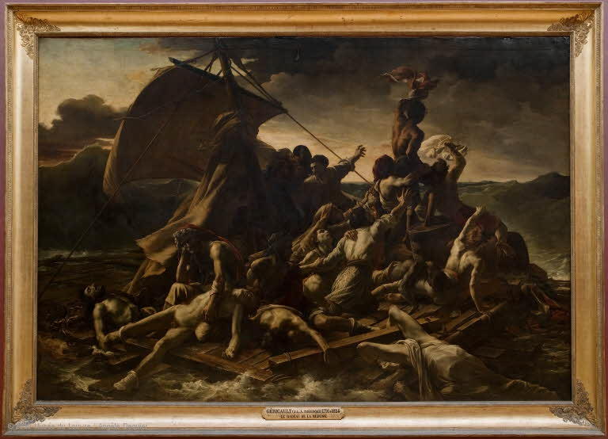
Gericault, (1819), available at: https://www.louvre.fr/en/oeuvre-notices/raft-medusa

There is a striking resemblance to The Raft of Medusa (1819) by Theodore Gericault. His piece depicted a disastrous ship sinking of the Mauretania coast due to the ruthlessness of the captain. Approximately 400 passengers died during this incident and those, who survived, suffered from hunger, dehydration and cannibalism. Gericault decided on the subject matter in response to the storm and outrage in the public domain.

Barca Nostra was originally a relatively small fishing boat. It was found some 60 miles off the coast of Libya and a fair distance from the famous immigrant receiving island in Italy called Lampedusa. This vessel was designed to carry just 15 crew members. It was loaded by ruthless traffickers with between 700 and 1100 migrants, who were used as the ballast and locked under the deck. Following a crash with a Portuguese ship, it sunk while killing all people imprisoned inside and only 28 people survived in total.
It is also of significance that, at that time, the EU suspended the Operation Triton, which was designed to keep the European border secure and help with the rescue of immigrant vessels in danger.
Subsequently, the location of the wreck was identified and raised to the surface at the cost of 9.5 million euros. The Italian government also launched a full-scale investigation into the accident and a long process of identification of the bodies in order to pay respect to the tragically killed and return them their dignity.
The Barca Nostra was ultimately raised from the seabed in 2016 and transported a NATO military base near Augusta in Sicily. This is where the painstaking process of body identification began, where the excavation and identification of bodies began. A square hole was cut on the side of the boat to recover the bodies, which were twisted inside – a really horrific scene became apparent, visible and overwhelmed both, the workers and the volunteers.
There was several proposals developed in order to secure the future of Barca Nostra as memorial, relic of human rights and mausoleum. Finally, Barca Nostra as a project by Christoph Büchel was given to the Community of Augusta in 2019.
During the currently opened, 58th Venice Biennale, Barca Nostra is exhibited at the Arsenale. This is a place of historical significance to the shipbuilding industry.
“BARCA NOSTRA surely is more than just a shipwreck; rather, it is a signifier of our reality, a relic of a human tragedy, as well as a monument to migration narrating the contemporary status of freedom of movement on a global scale. It is an indicator of collective responsibility and the horridness of nationalist discourses and current policies of the majority of European societies today.”
Balasz, (2019), available at: https://www.widewalls.ch/barca-nostra-christoph-buchel-ship-venice-biennale/

This piece also forces one to reflect on how unscrupulous criminal gangs will exploit vulnerable and desperate people in order to make money without any empathy or consideration for human life.
Critical Analysis of “How It Is?” by Miroslaw Balka (2008)
HOW IT IS?
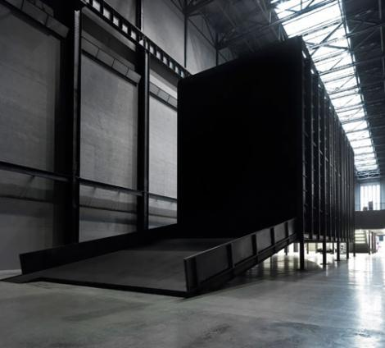
Balka, (2008), available at: https://www.studiointernational.com/index.php/the-unilever-series-miroslaw-balka-how-it-is

The Tate Modern commissioned Miroslaw Balka in 2008 to produce a piece of work for the Unilever Series at the Turbine Hall. Balka crated a gigantic steel container called “How It Is”. The structure is 13 meters high, 30 metres long and is placed on 13 metre stilts. The whole construction is risen from the floor making is possible for the viewers to walk around it, underneath it and inside through a ramp. This is of great significance and Arkette (2013) suggests that it makes references to death and the suffering of people during the war. It resembles similar ramps at the Ghetto in Warsaw and in Auschwitz and Treblinka concentration camps.
The piece also makes references to the risks taken by illegal migrants travelling in the hope of reaching better destinations and taking colossal risks, frequently losing their lives in dramatic circumstances after having been subjected to abuse and exploitation.
Balka creates an obscure theatre of darkness and fear, while allowing us to embrace and explore the unknown and making references to hell. His piece is static yet highly provoking, exciting and intriguing. As a matter of fact, both artefacts use the idea of darkness and confined space to manipulate their interpretation of human reactions and responses to uncertainty. These emotions refer to this specific moment rather than the general uncertainty of life and the world. It focuses people’s minds on the fragility of human existence and how susceptible we all are to being coerced to identify with the dilemmas of others. We are made to realise the level of out insignificance in an ever expanding Universe.
Arkette (2013) questions this piece and her interpretation is that through reducing the viewers’ visual perception, their auditory awareness is substantially enhanced. She expands on this by suggesting that absence is not visible and how can we perceive something that is not there: “can we be said to be seeing the absence of light?”
Therefore, we can see and experience the darkness, but not the content and this is the most important element of the piece. Our imagination is stimulated by darkness to produce overwhelming hallucinations of fear, anxiety and uncertainty. Therefore, it forces us to question our sub consciousness and the direction and purpose of the journey of life, while exposing our inner weaknesses.
Conclusion
Art allows us to experience uncertainty and risk in a totally different capacity to the sciences and philosophy. It deals with an emotionally charged reflection rather than an empirical analysis of these phenomena. Therefore, art formulates new perspectives of embracing and understanding the world, which are far beyond the empirical and tactile experiences.
The nature of art encourages people to create responses, which frequently provoke and disturb, fostering the consideration of ethics. This is of significance for society and brings a deeper thinking beyond politics and religion. It is deeply rooted in our knowledge of mortality and uncertainty. Therefore, both pieces are significant in theses contexts and attract a great amount of debate about humanity and ethical considerations.

Despite addressing the same idea and using a similar language, there is a clear contrast between both pieces. The first one is a functional object with a dramatic narrative, while the second is created to a developed specification in order to provide deep reflections and question our existence in the context of uncertainty.
However, both artefacts go beyond describing fear. They enable viewers to experience their uncertainties through a powerful use of absence to confront our deepest anxieties and worries. Both pieces give us an opportunity to step out of the comfort zone and force us to witness these terrifying situations by staring into a dark void. One piece opens up a broader dialogue, while the other encourages us to reflect on an actual event, identify with the victims and their struggle to survive. They both stimulate a broader political engagement, which is often ignored, but is a harsh reality affecting millions of people. Therefore, the use of absence to question presence proves to be a very powerful tool. This perhaps, is best expressed by Arkette (2013) in her critical analysis of the title. She manipulates it and states: “How It Is Not”.
These two artists articulate visually the discoveries by Heisenberg (1927) and reinforce the harsh truth of reality, which is very lucid, imprecise and “anschaulich” like. They also question the concept of risk as discussed by Ring (2016). Statistically, the chance of death during a migrant’s journey is relatively low as millions make it and thousands fail. However, the knowledge of uncertainty, they cling to an element of hope and imagine certainty. This can have either lethal consequences or lead to damaging their mental health. The calculation of probabilities and risks involved is clouded by optimism, self-belief and frequently prayers.
There is also cohesion in terms of Russell’s (1926) Theory of Knowledge.
The migrants differentiate between, what they are praying for and the reality of their position. Additionally, their situation is made much worse by a total lack of certainty of their success and precision of the practicalities, which are associated with their plans and the entire journey.
There is no knowledge, no certainty and no trust. The only support is in their blind hope.
The sensation of darkness and the echoes of the sounds reverberate to heighten the experience of nothingness, hopelessness and a paralysing rush of adrenaline. This is what Hume sees as the crucial element of the true knowledge – dramatic realisation of what is actually happening, while being able to feel that the end is imminent.
How can this be contextualised in such dramatic circumstances? Therefore, is it possible to achieve the full knowledge, while being imprisoned under the deck of a sinking vessel or inside of a gigantic and pitch-black void?
Sheer desperation flies in the face of Ellsberg’s (1961) philosophy of the human norm tasking the smallest risks. The belief in certainty in the context of uncertainty contradicts any possibilities for logical behaviour and contemplated reactions.
Human beings adapt different behaviours in different circumstances and contexts. This unpredictability of action and reaction can be, in turn, regarded as a key element contributing to the success of the human race. Nothing ventured, nothing gained!
Surprisingly, the idea of travelling on a boat can take place in a variety of contradictory contexts. This was realised by a provocative statement by Banksy, who has made a visual commentary on cruise-ships entering Venice. This opens a new dialogue and questions peoples’ presumptions and prejudice further as well as looks at the idea of certainty from a completely new perspective.
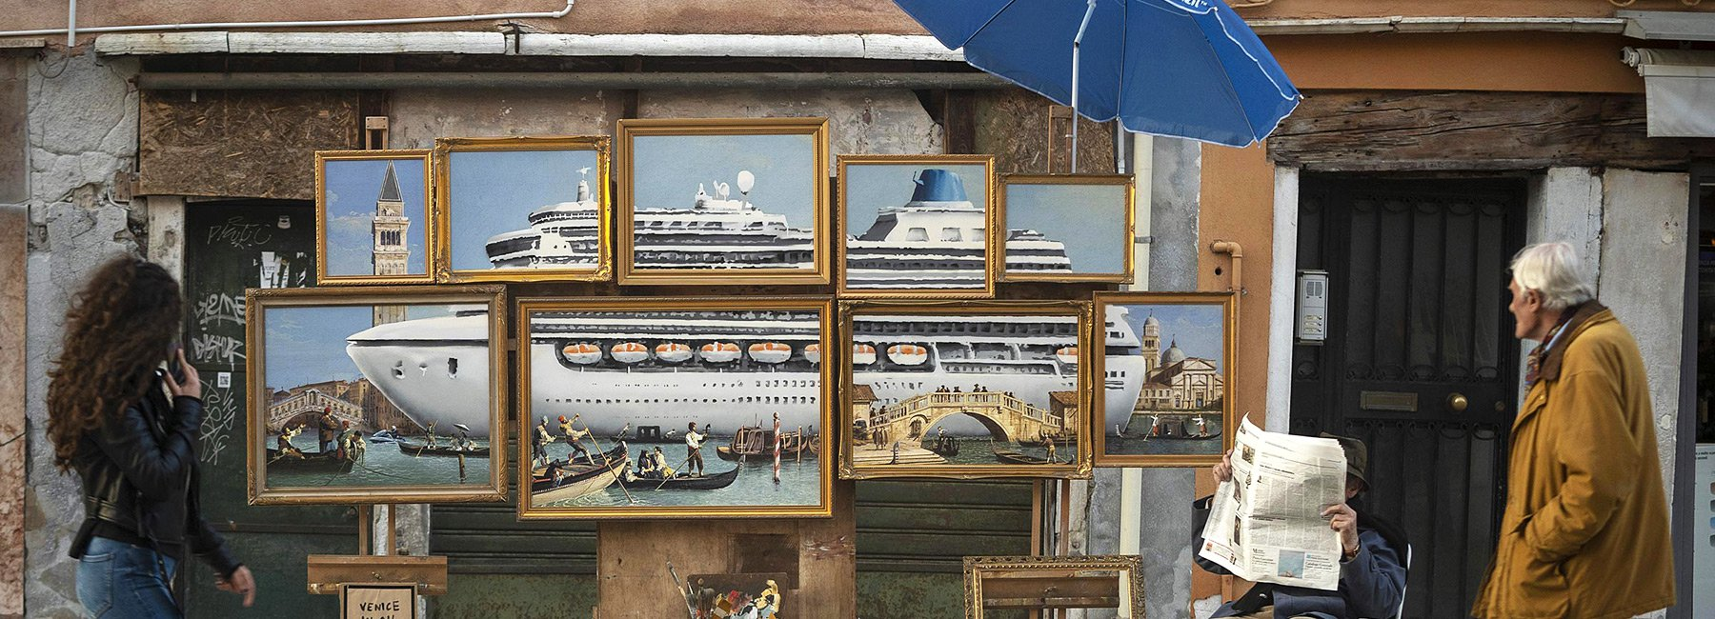
Banksy, (2019), available at: https://www.designboom.com/art/banksy-venice-art-biennale-paintings-05-22-2019/
REFERENCES:
Arkette, S. (2013) ‘The Unilever Series: Miroslaw Balka, “How It Is”’. Available at: https://www.studiointernational.com/index.php/the-unilever-series-miroslaw-balka-how-it-is.

Balka Miroslaw (2008) How It Is? Available at: https://www.studiointernational.com/index.php/the-unilever-series-miroslaw-balka-how-it-is (Accessed: 28 May 2019).

Banksy (2019) Unlicenced Street Stall. Available at: https://www.designboom.com/art/banksy-venice-art-biennale-paintings-05-22-2019/ (Accessed: 29 May 2019).

Borcherding, K., Larichev, O. I. and Messick, D. M. (eds) (1990) Contemporary issues in decision making. Amsterdam ; New York : New York: North-Holland : Distributors for the U.S. and Canada, Elsevier Pub. Co.

Büchel Christoph (2016) Barca Nostra. Available at: https://www.bbc.co.uk/news/world-africa-48252938 (Accessed: 28 May 2019).

Ellsberg Daniel (1961) Risk, Ambiguity, and the Savage Axioms.

Gericault Theodore (1819). Available at: https://www.louvre.fr/en/oeuvre-notices/raft-medusa (Accessed: 28 May 2019).

Harris, G. (2019) ‘Deadly boat that sank with hundreds of migrants on board becomes work of art at Venice Biennale’. Available at: https://www.theartnewspaper.com/news/after-mosque-row-christoph-buechel-returns-to-the-venice-biennale-with-migrant-shipwreck.

HEISENBERG WERNER (1927) ‘"Ueber den anschaulichen Inhalt der quantentheoretischen Kinematik and Mechanik”, Zeitschrift für Physik, 43: 172–198.’ Available at: https://plato.stanford.edu/entries/qt-uncertainty/ (Accessed: 27 May 2019).

HEISENBERG WERNER (1958) ‘PHYSICS AND PHILOSOPHY: The Revolution in Modern Science’, New York HARPER & BROTHERS PUBLISHERS, Volume Nineteen, p. 201.

Hilgevoord, Jan and Uffink, Jos, (2001) ‘The Uncertainty Principle’, The Stanford Encyclopedia of Philosophy, (Winter 2016 Edition). Available at: https://plato.stanford.edu/entries/qt-uncertainty/ (Accessed: 27 May 2019).

Ihas Alok (2013) ‘What is Heisenberg’s Uncertainty Principle?’, The Guardian. Available at: https://www.theguardian.com/science/2013/nov/10/what-is-heisenbergs-uncertainty-principle (Accessed: 27 May 2019).

Meaning Ring (2016) ‘The Difference between Risk and Uncertainty’. Available at: http://meaningring.com/2016/05/21/ambiguity-aversion-by-rolf-dobelli/ (Accessed: 27 May 2019).

Prichard Harold (2017) Kant’s Theory of Knowledge. Jovian Press, 4-Philosophy.

Rana Zat (2018) ‘David Hume: Balanced Skepticism’. Available at: https://designluck.com/david-hume-skepticism/ (Accessed: 27 May 2019).

Russell, B. (1914) Our Knowledge of the External World as a Field for Scientific Method in Philosophy. London: George Allen & Unwin Ltd. Available at: https://archive.org/details/ourknowledgeofth005200mbp/page/n9. (Accessed: 31 May 2019).

Russell Bertrand (1926) ‘Theory of Knowledge’, for The Encyclopaedia Britannica). Available at: https://www.marxists.org/reference/subject/philosophy/works/en/russell1.htm (Accessed: 27 May 2019).

Takac Balasz (2019) ‘Barca Nostra - Christoph Buchel Brings a Shipwreck to Venice Biennale’. Available at: https://www.widewalls.ch/barca-nostra-christoph-buchel-ship-venice-biennale/ (Accessed: 28 May 2019).

